1. Deploy your your previous assignment flask frontend and express backend in kubernetes cluster locally with minikube.
Screenshots:
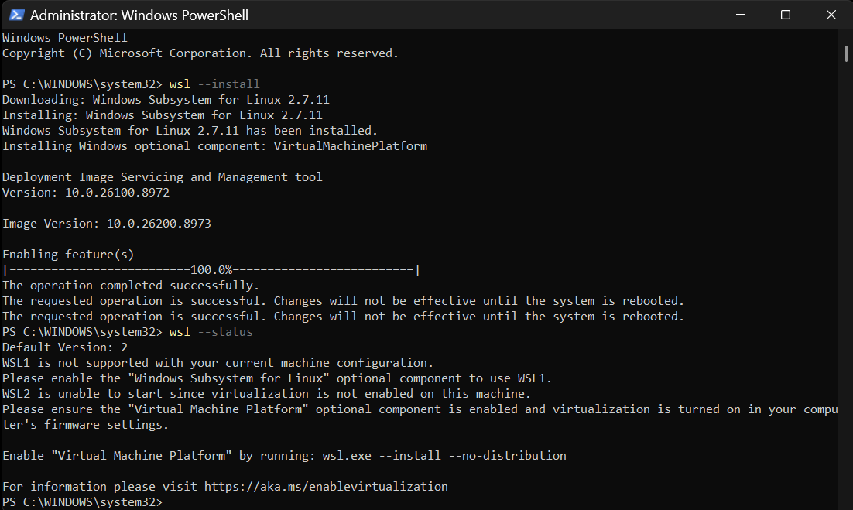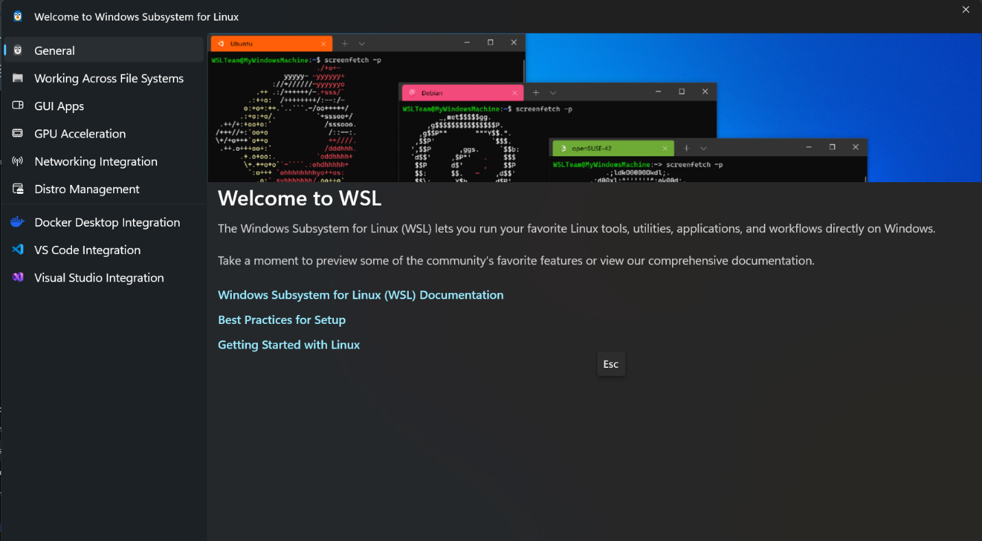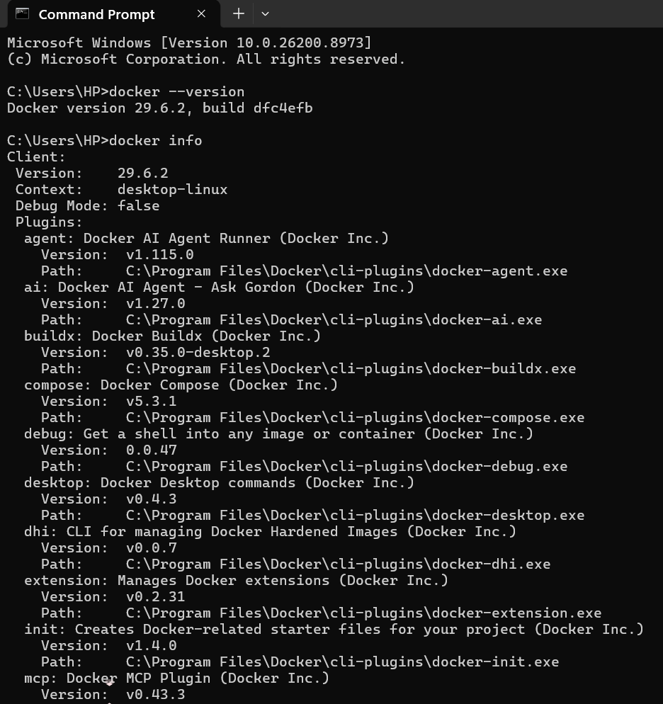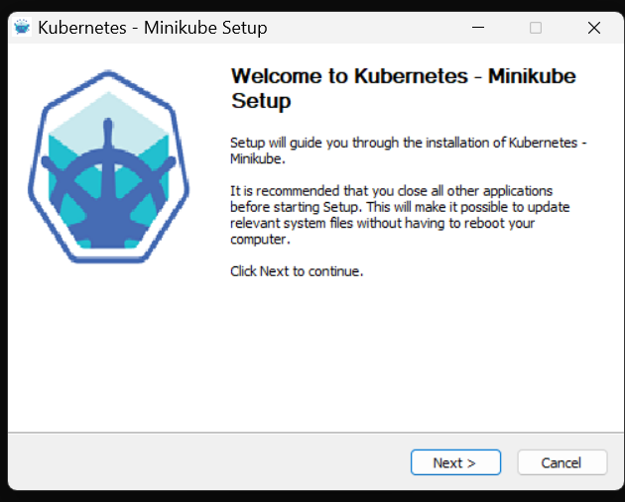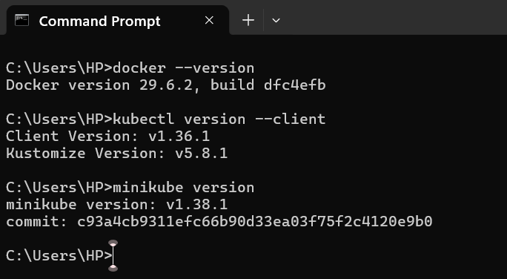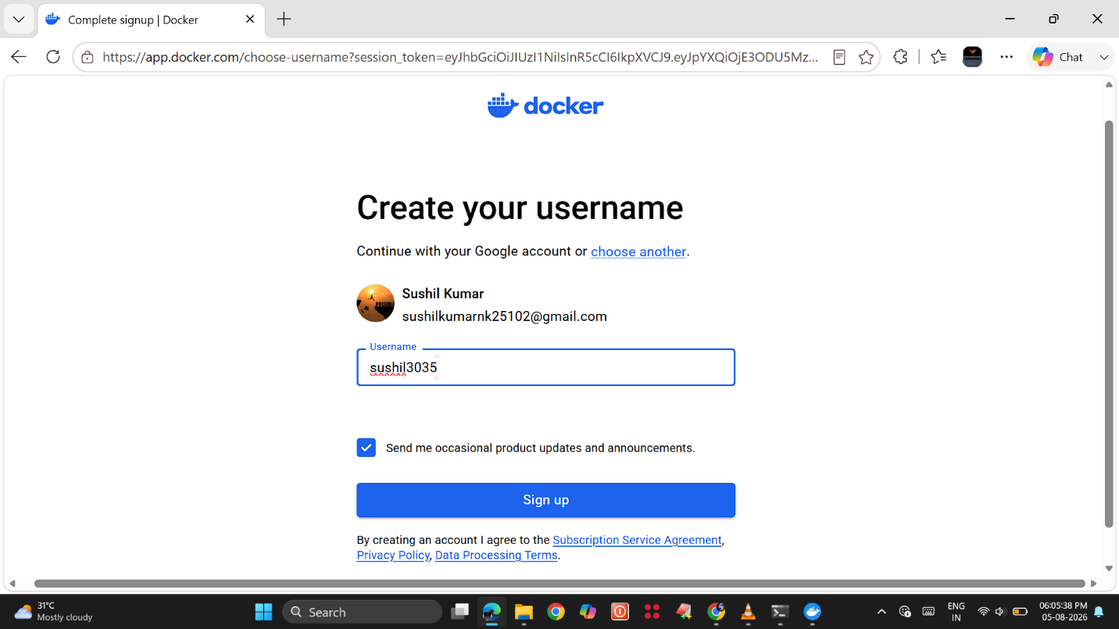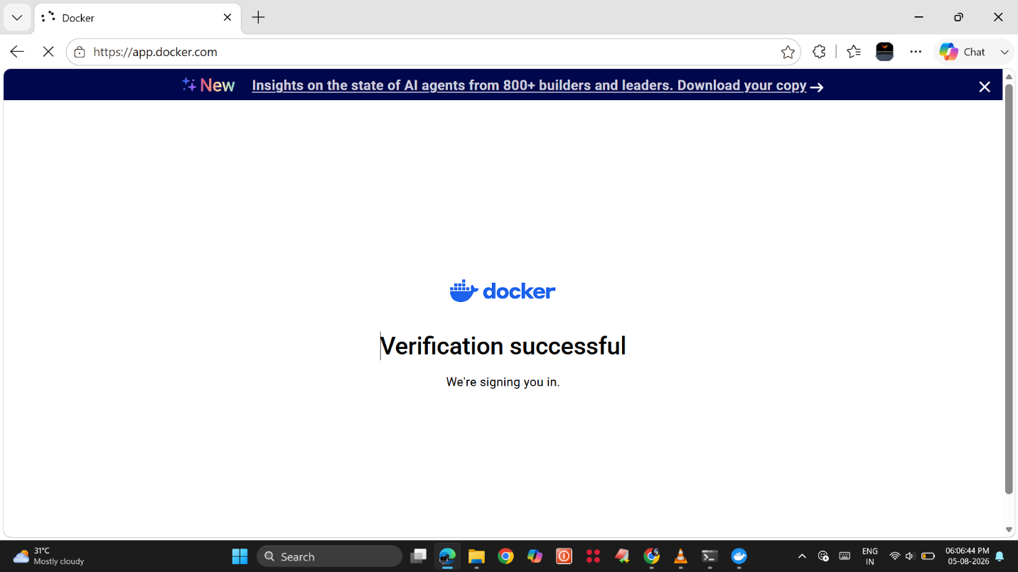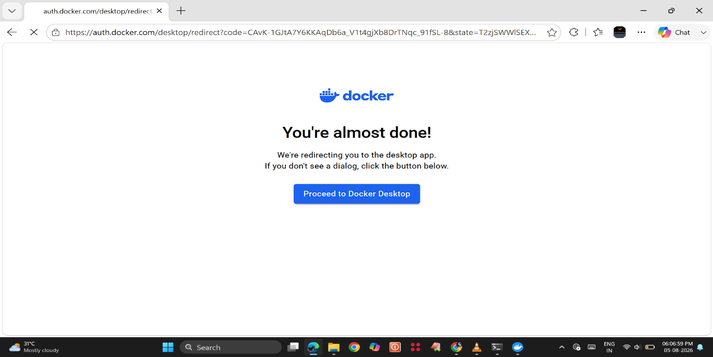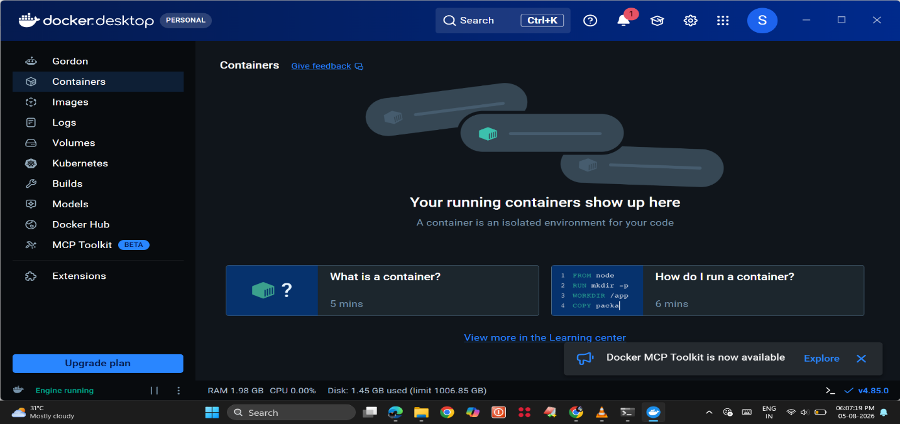
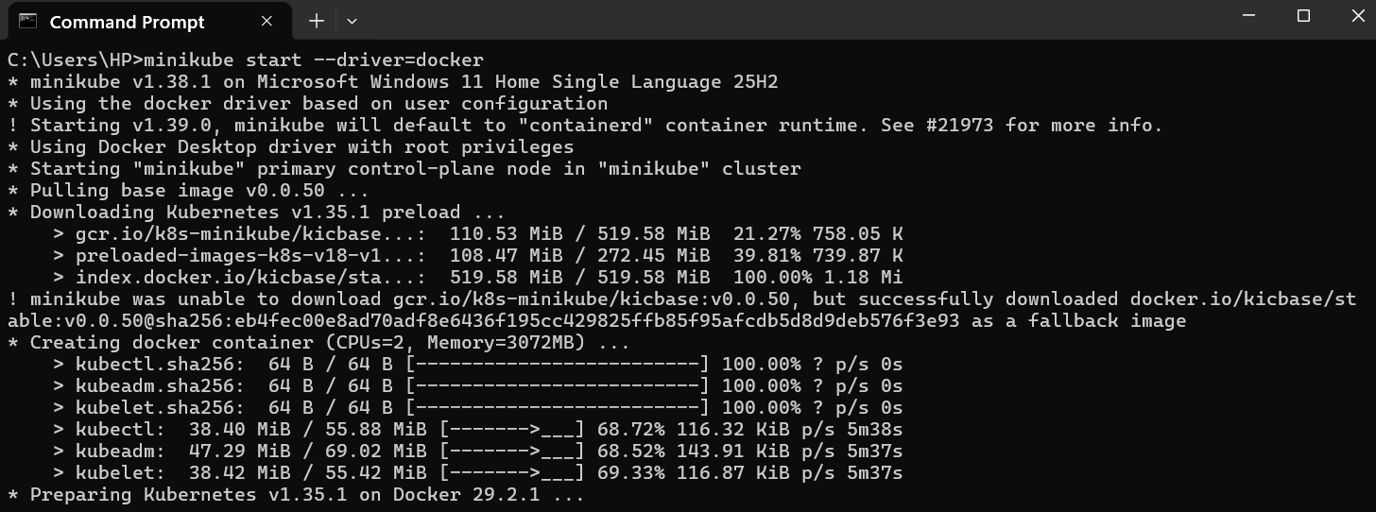
Commands:
minikube start --driver=docker
kubectl get nodes
docker build -t flask-frontend ./frontend
docker build -t express-backend ./backend
kubectl apply -f frontend-deployment.yaml
kubectl apply -f frontend-service.yaml
kubectl apply -f backend-deployment.yaml
kubectl apply -f backend-service.yaml
kubectl get pods
kubectl get svc
kubectl get deployments
minikube service flask-service
minikube service express-service

Git hub Repository Link:

